Attention: 1) Preview the handout and pre-class reading materials.
2) Print the file as you need for class use.
Lesson 12 Reading and Writing the Body (II)
The Discussion
Lesson Objectives:
- Learn some basic information about the Discussion
- Identify the structure of the Discussion
- Learn to express limitations in the Discussion
- Learn to handle strength of claim

- Reviewing writing the Methodology

- Getting to know the Discussion
  - What does the Discussion/Conclusion section do?

2.2. Getting to know the Discussion
Ex. 12-1 Do you agree (A) or disagree (D) to these statements? And why?
______ 1. Discussion sections should be short and to the point. It is better to let Results sections speak largely for themselves.
______ 2. A long Discussion section shows that the author or authors are able to reflect intelligently on what was found.
______ 3. Discussions are rarely necessary. Readers can draw their own conclusions. If readers want a summary, they can always read the abstract。
______4. The Discussion section often alternates between the past tense (when discussing results of current study “we found”) and the present tense (“our results are consistent with” or “the theory of natural selection predicts that”).When referring to specific results or methods, use the past tense, but use the present when presenting conclusions (“we conclude that gene X is dispensable for ornithine synthesis”). However, the Discussion may include the future tense if directions for additional research or scholarship are brought up (e.g., “the methods reported here will allow for rapid screening in the field” or “we will publish the full results of our screen as part of another study”).

2.3. Different combinations of the Discussion
This section of a research paper can be labelled differently. Work in your team to check on alternative labels or arrangements in your collection of journal articles.

  - Comparing the Results and the Discussion

Ex. 12-2 Work in teams to identify differences between the Results and the Discussion.
Here are parts of the Results (Section 3.1) and the Discussion (Section 4) of an article reporting on how divided attention affects a pedestrian's ability to safely cross a busy street. The study was conducted in a simulator where students walked on a treadmill. While crossing a virtual street, students were distracted by a cell phone conversation or by listening to music on an MP3 player. What significant ways do the texts in the two sections differ? In what ways are they similar? Create a list highlighting your findings. You can refer to the checklist below for your reference:
- research questions,
- statistics,
- findings,
- tables,
- reference to previous studies,
- evaluative statements.

Pedestrains, Vehicles and Cell Phones
Neider, M.B., McCarley, J.S., Crowell, J.A.,
Kaczmarski, H., and Kramer, A.F.(2010)
Accident Analyisi &Prevention, 42, 589-594

3.1. Crossing success rate
Is the likelihood of safely crossing a street influenced by the number or types of tasks a pedestrian is concurrently engaged in? To answer this question we analyzed the percentage of trials in which observers successfully crossed the road (Talbe 2). If listening to music or conversing on a cell phone impaired performance, then we would expect success rates in those conditions to be lower than in the no distraction condition. An ANOVA performed with distraction as a within-subjects factor partially confirmed this prediction, F(2,70)=3.96, p<0.05, ŋp2=0.1. Participants crossed successfully approximately 84% of the time when undistracted and nearly 85% of the time when listening to music, compared to 80% of the time when talking on a cell phone; listening to music induced no performance cost relative to the no distraction condition (p=0.53). Conversing on a cell phone produced significantly lower success rates than listening to music (p<0.01). Participants trended towards poorer performance when conversing on a cell phone compared to the no distraction condition, but the post hoc comparison did not reach significance (p=0.09).
Table 2. Mean Overall Trial Duration(s), Crossing Success Rates, Collision Rates, and Rate of Errors from Time Outs
 | Trial Duration | Success Rate | Collision Rate | Time Out Rate
No distraction | 11.73(0.62) | 83.85(1.81) | 14.49(1.73) | 1.65(0.47)
Cell phone | 13.27(0.52) | 80.20(2.32) | 15.45(2.03) | 4.34(1.01)
Ipod | 11.47(0.57) | 84.98(1.83) | 13.67(1.60) | 1.65(0.56)
Note: Values in parentheses indicate one standard error of the mean.
[The remainder of the Results section has been omitted.]

4. Discussion
Consequential Explanation
Field studies (e.g.,[Hatfield and Murphy, 2007] and [Nasar et al., 2008]) have observed that pedestrians make more unsafe street crossings when conversing on a cell phone than when undistracted. Our findings provide partial experimental confirmation of these observations. Participants were less likely to successfully cross the street in our task when they were conversing on a cell phone than when they were listening to music on an iPod. Furthermore, engaging in a cell phone conversation while crossing the street led to higher time out rates in our virtual street-crossing task than did listening to music or performing the task distracted. Additionally, participants took more time to initiate a crossing when conversing on a cell phone, and walked more slowly during crossing. The last result is consistent with data from field studies of pedestrian street crossing that have observed slower walking during cell phone conversations (e.g., [Hatfield and Murphy, 2007] and [Nasar et al., 2008]).
Exposition
The fact that our successful crossing rates were somewhat low (one would certainly hope that in the real-world pedestrians successfully cross the street more than 84% of the time) might suggest that our task was artificially difficult, and hence not representative of the real world. As noted, though, most of the failures to cross successfully were the result of the trial coming out, not the result of collision. The low rate of successful crossing, therefore, does not suggest that the simulated environment or tasks was unduly hazardous. Pilot data collected in preparation for the current study (identical task but with vehicles travelling at a constant speed and distance from each other), moreover, found similar effects of distraction, even when the crossing task was substantially easier. In the pilot testing, parameters for car movement and density allowed participants to successfully cross the road 99% of the time in the no distraction and music listening conditions, success rates far higher than observed in the present study. Nonetheless, successful crossing rates declined in the cell phone condition, falling to 97% (differences not significant), resulting in a pattern of data that was somewhat similar to that which we report in the current study.
[The remainder of the Discussion section has been omitted.]

Checklist for your reference:
Results | Discussion
Research questions | Findings
Statistics | No statistics, or only a few
References to the results of previous studies
Experimental conditions not related to real-world situations

  - Features of the Discussion (compared with the Results)
- more theoretical
- more abstract
- more general
- more integrated with the field
- more connected to the real world
- more concerned with implications and applications
- more likely to discuss the limitations of the study

  - Genre analysis of the Discussion
Typical genres applied to the Discussion section are:
- discussion (issue → sides → resolution)
- exposition (thesis → arguments → reiteration)
- factorial explanation
- consequential explanation

Ex. 12-3 Analyze the genre of the Discussion (Section 4) of the article Pedestrians, Vehicles and Cell Phones and check your answers with your partner(s).

- Getting to know the structure of the Discussion
3.1 The Structure of the Discussion/Conclusion
Move 1--Background information  (research purpose, theory, methodology)  Move 2--Summarizing and reporting key results  Move 3--Commenting on the key results  (making claims, explaining the results, comparing the new work with the previous studies, offering alternative explanations)  Move 4--Stating the limitations of the study  Move 5--Making recommendations for future implementation and/or for future research  PISF=probable in some fields | Optional, but PISF  Obligatory  Obligatory  Optional, but PISF  Optional

3.2. Identify moves of the Discussion
Read the Discussion of the academic articles you chose. What moves can be identified in them? Be prepared to exchange your findings in your team.

  - Re-assemble a conclusion/implication part in the Discussion
Ex. 12-4 Here are six sentences taken from the Conclusions/and Implications of the Swales and Leeder (2012) paper. Re-assemble them into their original order.
___3___ a. Further down the rankings, one could also note Myers’ important conclusions of what a textbook is educationally good for and less good for.
___5___ b. Despite this uncertainty, we can recommend an alternative approach to a well-explored discipline, a standard study but of an under-researched area, or an unusual topic in a well-known genre.
___1___ c. Although it is hard in some ways to draw firm conclusions from our data, there is little doubt that three general factors have led to the citational success of the 15 articles in our core group: choosing academic English; using discourse analysis; and having something new to say.
___4___ d. Since this paper has investigated part of the story of the English for Specific Purposes Journal in the 1990s, comparable stories of the preceding and the following decade will likely turn out to be very different.
___2___ e. We can see this in Mauranen’s innovative metaphorical contrast between her two groups of economists and in Salager-Meyer’s powerful quantitative analysis.
___6___ f. In consequence, the implications for today’s rising young scholars (both NS and NNS) must remain tentative.

  - Team discussion：
Ex. 12-5 Read the following Discussion and make your team decision on the writer’s purpose in writing each sentence and find which move each sentence belongs to.

Cognitive-behavioral stress management(CBSM) skills and quality of life in stress-related disorders  Discussion  1 Prior work has documented the effectiveness of psychosocial intervention in improving quality of life(QoL) and reducing stress in patients suffering from various disorders; Epstein, for example, reports that orthopedic patients participating programme improved across several QoL indices, including interpersonal conflict and mental health.  2 However, these studies have either been short-term studies or have not focused on patients whose disorder was stress-related. 3 In this study we tested the extent to which an extended three-month stress management programme improved QoL among a group of patients being treated for stress-related skin disorders such as eczema.  4 We found that in virtually all cases, participation in our three-month stress management programme was associated with substantial increases in the skills needed to improve QoL. 5 These findings extend those of Kaliom, confirming that a longer, more intensive period of stress-management training tends to produce more effective skills than when those skills are input over a shorter period via information transfer media such as leaflets and presentations (Kaliom et al., 2003). 6 In addition, the improvements noted in our study were unrelated to age, gender or ethnic background. 7. This study therefore indicates that the benefits gained from stress-management intervention may address OoL needs across a wide range of patients.  8. Most notably, this is the first study to our knowledge to investigate the effectiveness of extended psychosocial intervention in patients whose disorder is itself thought to be stress-related. 9. Our results provide compelling evidence for long-term involvement with such patients and suggest that this approach appears to be effective in counteracting stress that may exacerbate the disorder. 10. However, some limitations are worth noting. 11. Although our hypotheses were supported statistically, the sample was not reassessed once the programme was over. 12. Future work should therefore include follow-up work designed to evaluate whether the skills are retained in the long term and also whether they continue to be used to improve QoL. | - ______________  - _______________  - ______________  - ______________  - _____________  - ____________  - ____________  - _____________  - ____________  - _____________  - _____________  - _____________

- How to express limitations in the Discussion
  - Why to use less negative language?

  - Useful sentence patterns to express limitations
Here are some typical formulations for stating limitations in one's research scope.
It should be noted that this study has been primarily concerned with ....
This analysis has concentrated on ....
The findings of this study are restricted to ....
This study has addressed only the question of ....
The limitations of this study are clear: ....
We would like to point out that we have not ....
Here are some typical openings for statements that firmly state that certain conclusions should not be drawn.
However, the findings do not imply ....
The results of this study cannot be taken as evidence for ....
Unfortunately, we are unable to determine from this data ....
The lack of... means that we cannot be certain ....
If you feel it is unnecessary to comment on your work in either of these two ways, a useful alternative is to place the limitation in an opening phrase. At least, it does not express academic modesty.
Notwithstanding its limitations, its study does suggest ....
Despite its preliminary character, the research reported here would seem to indicate ....
However exploratory, this study may offer some insight into ....

- Language Focus: Strength of Claim
Two requirements for your claim:
to be cautious / (critical) about data
to qualify / moderate a claim & indicate your stance toward your claim

  - Evaluating the strength of claims
Ex. 12-7 Evaluate the strength of each of the alternatives on the basis of the statement:
Many studies have concluded that excessive credit growth ___ the global financial crisis.
- contributed to
- caused
- may have contributed to
- was probably a major cause of
- was one of the causes of
- might have been a factor in
Strong →Weak: ___________________

  - Moderating / Qualifying a claim
- Likelihood
The use of a modal auxiliary
Notice the degree of strength / cautiousness in the following expressions:
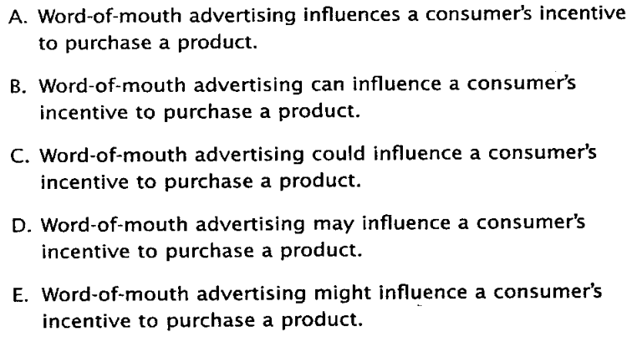
The use of weakening expressions
How does the strength vary in degree in the following sets?
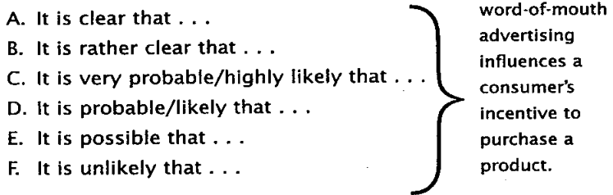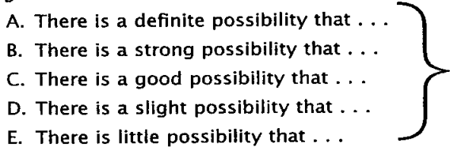
- Distance: removing yourself from a strong / unjustified claim
Attribute your point to other researchers/studies, e.g.:
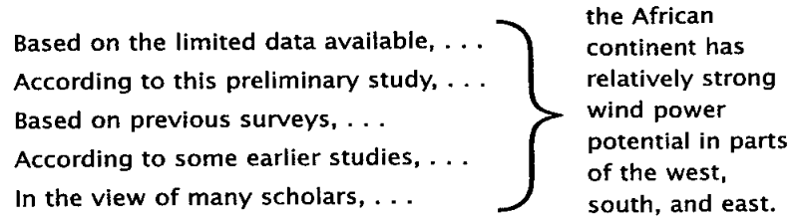
- Softening Generalizations
- Classic verbs: appear (to), seem (to), tend (to) (e.g. on slide):
Children living in poverty appear to do poorly in school.
Children living in poverty seem to do poorly in school.
Children living in poverty tend to do poorly in school.
vs.
Children living in poverty do poorly in school.
- Qualifying / Limiting the subject:
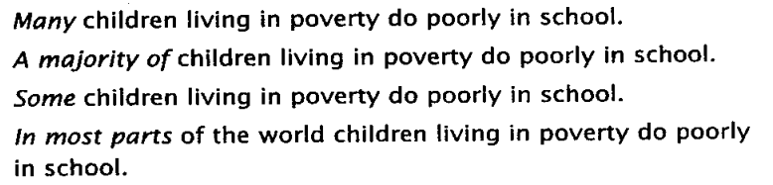
- Adding exceptions
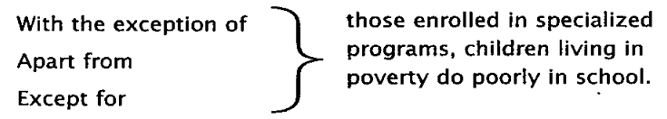
- Weaker Verbs to indicate your level of commitment to your claim
See Ex. 13-5: What are the two verbs used?
Many studies have concluded that excessive credit growth caused the global financial crisis.
Many studies have concluded that excessive credit growth contributed to the global financial crisis.

- Combined Qualifications to be “confidently uncertain”

Ex. 12-8 Examine the strong claim: When people have too many choices, they choose the safest one. Try to add distance, then weaken the generalization, and then indicate likelihood.

  - Practice on the Language Focus
Ex. 12-9 Choose the verb that makes the weaker claim:
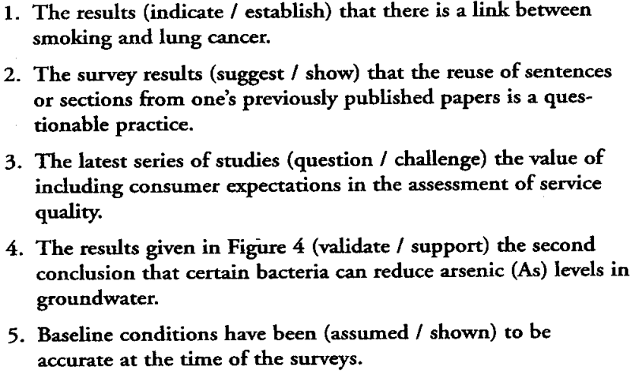
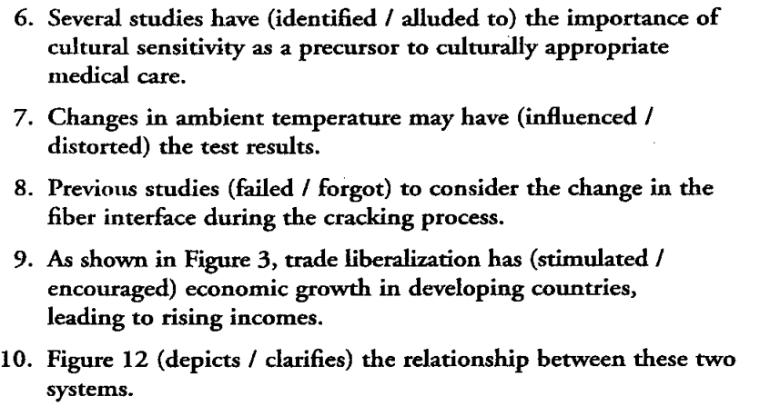

Ex. 12-10 Soften the claims and make the statements academically respectable and defensible.
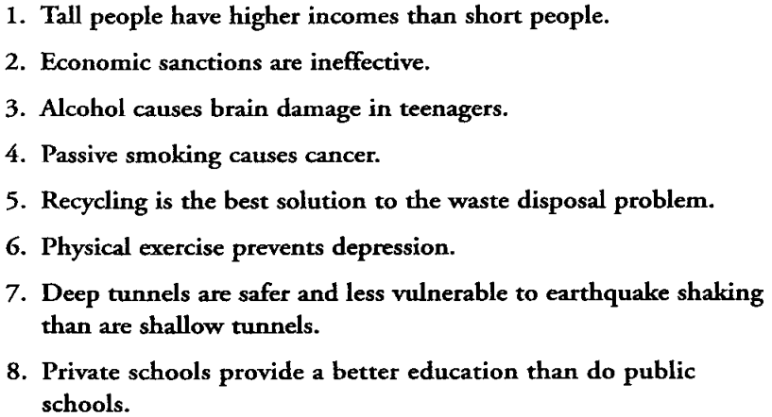
Homework Assignments:
1. Read the Discussion sections in your collection of journal articles and underline the sentences which express limitations. Identify them as the typical formulations, typical openings for statements, or opening phrases.

2.Study the extract below from a journal article. For each pair of phrases in bold in the text, circle the one which is more formal and academic in style.

Corporate social responsibility and cause-related marketing: an overview
Introduction
It is generally recognized that today's marketplace is characterized by a great many products of similar quality, price and service. 1. Because they ever increasingly need/ In their ever-increasing need to differentiate themselves and their product, many companies are reacting positively to the idea 2. that they can use/of the use of cause-related marketing(CRM) as a communications tool. Basically, the concept entails firms communicating through their advertising, packaging and promotions, 3. their corporate social responsibility/ the fact that as a corporation they feel responsible for society, namely their affiliation with non-profit organizations or support for causes. The point is to attract consumers wanting to make a difference in society through 4. their purchasing decisions/deciding which items they should purchase. However, consumers are now looking closely at companies who make claims regarding 5. their involvement in social issues/how they are involved in social issues. There is a level of consumer skepticism that often makes consumers doubt what a firm is saying. It has even been suggested that because so many firms are now using CRM, skepticism is on the rise. (O'Sullivan, 1997; Mohr et al., 1998). This skepticism can lead consumers to reject claims made in CRM campaigns and can affect 6. the way they behave when they make purchases/ their purchasing behavior and can even lead 7. them to act more strongly/ to stronger action (Rogers, 1998). Therefore, not only is it important for companies pursuing CRM to be genuine in their behavior but they must also fully understand what consumers know of CRM and their level of skepticism before attempting this marketing technique.
(Simcic BrøP. and Belliu Vrioni, A. (2001) "Corporate social responsibility and cause related marketing: an overview" International Journal of Advertising, 20, pp. 207-222)

Attached file:
Vocabulary for the Discussion
Read the vocabulary for the Discussion/ Conclusion. Think about your use of words in writing your own Discussion/ Conclusion.）

This file mainly focuses on the following areas:
- Mapping (relationship to existing research)
- Achievement/contribution
- Limitations/current and future work
- Applications

- Mapping (relationship to existing research)
This/Our study/method/result/ approach is:  analogous to  comparable to  compatible to  consistent with  identical (to)  in contradiction to  in contrast to  in good agreement (with)  in line with  significantly different (to/from)  the first of its kind  (very/remarkably) similar (to) unlike | This/Our study:  broadens  challenges  compares well (with)  confirms  contradicts  corresponds to  corroborates  differs (from)  extends  goes against  lends support to  mirrors  modifies  proves  provides insight into  provides support for  refutes  supports  tends to refute  verify

Examples of how these expressions are used:
- To the knowledge of the authors, the data in Figs. 4-6 is the first of its kind.
- The results of this simulation therefore challenge Laskay’s assumption that percentage porosity increases with increasing Mg levels.
- The GMD method provides results that are comparable to existing clay hydration processes.
- Similar films on gold nanoparticles have also been found to be liquid-like.
- Using this multi-grid solver, load information is propagated faster through the mesh.
- Our results are in general agreement with previous morphometric and DNA incorporation studies in the rat.
- Our current findings expand prior work.
- The system described in this paper is far less sensitive to vibration or mechanical path changes than previous systems.
- Unlike McGowan, we did not identify 9-cis RA in the mouse lung.

- Achievement/Contribution
Science writing does not generally permit the use of the exclamation mark (!), but the vocabulary used to state your achievement or contribution can still communicate that the achievement is exciting. The vocabulary list has therefore been divided into two sections; the first is a list of !-substitutes, which can be used when the achievement is very exciting, and the second is a list of slightly ‘cooler’— but still positive —language.
!-substitutions
compelling  crucial  dramatic  excellent  exceptional  exciting  extraordinary  ideal  invaluable  outstanding | overwhelming  perfect  powerful  remarkable  striking  surprising  undeniable  unique  unusual  unprecedented  vital

Positive language
accurate  advantage  appropriate  attractive  beneficial  better  clear  comprehensive  convenient  convincing  correct  cost-effective  easy  effective  efficient  encouraging  evident  exact  feasible  flexible  important  low-cost  novel  productive  realistic  relevant  robust  simple  stable  straightforward  strong  successful  superior  undeniable  useful  valid  valuable | assist  compare well with; confirm  could lead to  enable  enhance  ensure  facilitate  help to  improve  is able to  offer an understanding of  outperform  prove  provide a framework  provide insight into  provide the first evidence  remove the need for  represent a new approach to  reveal  rule out  solve  succeed in  support  yield

Examples of how these expressions are used:
- The presence of such high levels is a novel finding.
- We identify dramatically different provides in adult lungs.
- Our results provide compelling evidence that this facilitated infection.
- These preliminary results demonstrate the feasibility of using hologram-based RI detectors.
- Our data rule out the possibility that this behavior was a result of neurological abnormality.
- The system presented here is a cost-effective detection protocol.
- A straightforward analysis procedure was presented which enables the accurate prediction of column behavior.
- Our study provides the framework for future studies to assess the performance characteristics.
- We have made the surprising observation that Bro1-GFP focus accumulation is also pH –dependent.
- We have derived exact analytic expressions for the percolation threshold.
- Our results provide a clear distinction between the functions of the pathway proteins.

- Limitations/Current and future research
You will normally outline the limitations of your own work, but this is not expressed as a problem with your work, rather it provides suggestions for future work. This invitation to the research community improves the status of your work by communicating that there is much research to be done in this area.
Note that using will/or the Present Continuous (e.g. we will integrate/we are integrating this technique with the FEM implementations) communicates your own intentions or work in progress; should is used to invite research from others (This technique should be integrated with the FEM implementations).
a/the need for  at present  encouraging  fruitful  further investigation  further work is needed  further work is planned  future work/studies should  future work/studies will  in future, care should be taken  in future, it is advised that…  holds promise  interesting  it would be beneficial/useful | possible direction  promising  recommend  remain to be (identified)  research opportunities  should be explored  should be replicated  should be validated  should be verified  starting point  the next stage  urgent  worthwhile
Examples of how these expressions are used:
- Our results are encouraging and should be validated in a larger cohort of women.
- However, the neural mechanisms underlying these effects remain to be determined.
- This finding is promising and should be explored with other eukaryotes.
- Future work should focus on the efficacy of ligands synthesized in the Long group.
- An important question for future studies is to determine the antidepressant effects of such drugs.

- Applications/Applicability/Implementation
Research work does not always have a clear application. However, in some cases, it is clear how the work can be used, particularly if your project has resulted in a device or product of some kind. In such cases, you should indicate possible applications or applicability, and in many cases this can be derived from points made earlier in the Introduction. Don’t forget to use modal verbs such as could, should and may.
Eventually  In future  Soon  possible | Apply  Have potential  Implement  Lead to  Produce  Use  Utilize
Examples of how these expressions are used:
- Our technique can be applied to a wide range of simulation applications.
- The PARSEX reactor therefore could be used for the realistic testing of a wide range of control algorithms
- It should be possible, therefore, to integrate the HOE onto a microchip.
- This approach has potential in areas such as fluid density measurement.
- The solution method could be applied without difficulty to irregularly-shaped slabs.
- Our results mean that in dipping reservoirs, compositional gradients can now be produced very quickly.
- This could eventually lead to the identification of novel biomarkers.

